REGNO:1518102085

DATE:22.11.2020

EX NO:14

Aim:

Write a Python class to find validity of a string of parentheses, '(', ')', '{', '}', '[' and ']. These brackets must be close in the correct order

Program:

class validity:

def f(str):

a=['()','{}','[]']

while any(i in str for i in a):

for j in a:

str=str.replace(j,'')

return not str

s=input()

if(validity.f(s)):

print("Valid")

else:

print("invalid")

LINK:

http://103.53.53.18/mod/vpl/forms/edit.php?id=326&userid=1696

Output:

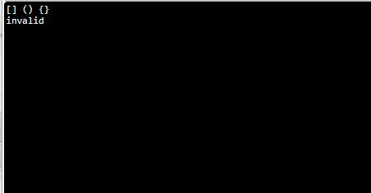

Result:

A python class is written to find validity of a string of parentheses, '(', ')', '{', '}', '[' and ']. These brackets must be close in the correct order